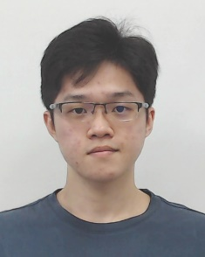**FOCS_StudF03: Student’s Progress Report**

Attached a photo here

(use digital photo)

**Tunku Abdul Rahman University College**

**Faculty of Computing and Information Technology**

**Industrial Training Progress Report**

Activity Log

|  |  |
| --- | --- |
| Name of Trainee: | Kong Mun Jun |
| Name of Company: | Ezee Technosys (M) Sdn Bhd |
| Month/Year: | February / 2022 |

|  |  |
| --- | --- |
| **Week** | **Projects / Activities** |
| **1** | Chinese New Year Holiday |
| **2** | Company treat us with a 2 Days 1 Night Seremban Trip, we had lots of fun and ice breaking with all the colleagues in the company. On Wednesday, I and other interns were introduced with another on premise system and given tasks by our leader to familiarise the system’s features and availability. |
| **3** | First day of this week, we were assigned with another task which is On Site Training, we form into a team of 2 and brought to a hotel to do case study. We had to understand every flow and process of how the staff uses the on premise system to fulfill the hotel daily task. The On Site Training last for 3 days and after that we had to do a report to discuss about the case study for the hotel. |
| **4** | After the on site training, we complete a case study report and prepare a presentation slide to present the case study as well. Then, we went into a training to learn how to function their own Point of Sales system which are eZee Optimus and eZee Burrp! |

**Suggestions / Comments / Additional information (if any):**



**Leave Application / Leave Taken**

1. From (dd/mm/yyyy) ___09/02/2022___ to (dd/mm/yyyy) ____09/02/2022__ ( __½__ days)

2. Reasons for taking leave: Shoulder dislocated have to go Tit Tar (铁打)

3. Total number of days taken:___Half Day__________________________________________

**I hereby declare that the information given above is correct.**

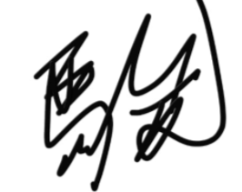

**Signature**: _____________________ **Date**: ___25/02/2021__

*(dd/mm/yyyy)*



|  |  |  |  |
| --- | --- | --- | --- |
| **Endorsement by the Company Supervisor:** | | | |
| **The above is a true record of activities taken by the trainee in the captioned week.** | | | |
| Signature of Supervisor: | __________________________ | | |
| Name of Supervisor: | __________________________ |  |  |
| Date: | *(dd/mm/yyyy)*_______________ |  |  |
| Email: | __________________________ |  |  |
| Mobile / Office Contact No.: | __________________________ |  |  |
| Company Stamp: | Company stamp with address |  |  |

